- Create 3 commits.

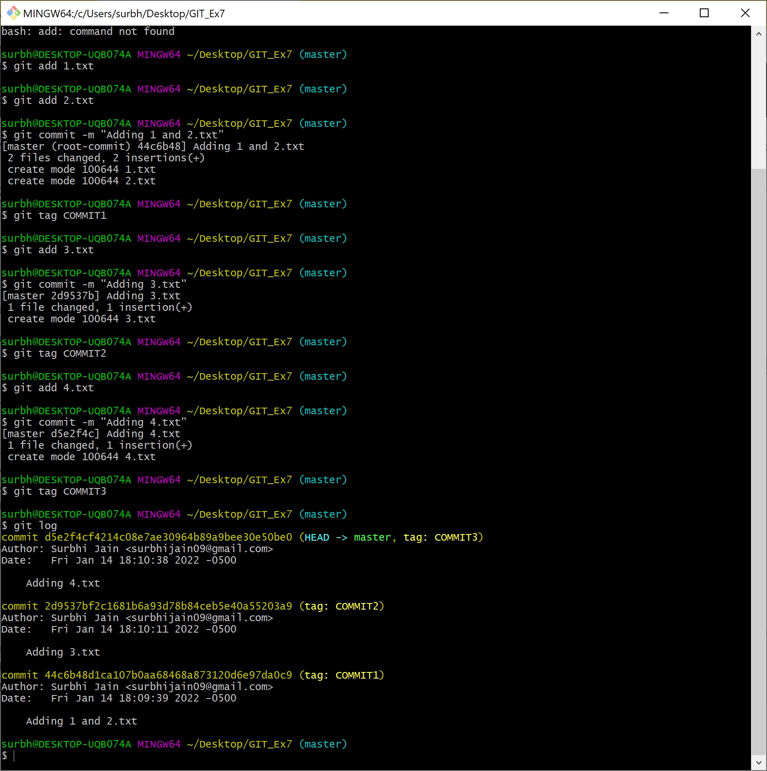

- Make changes to 1.txt, 4.txt and 3.txt and commit them.

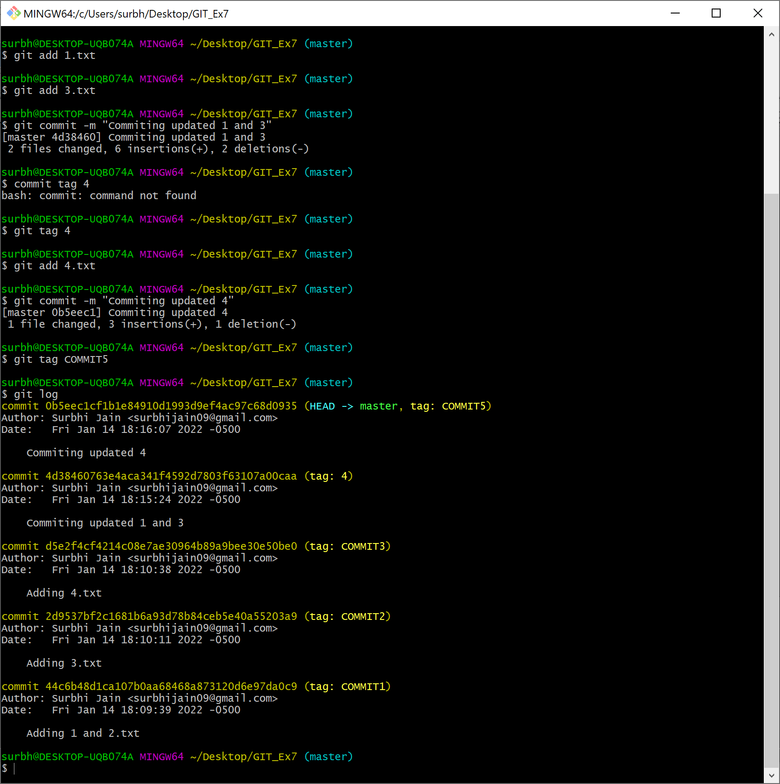

- Now Hard reset to Commit3.

4. The 1, 3 and 4.txt files are back to their original state. The changes made in Commit5 and 4 are also gone in the working directory.

